Field-scale evaluation of infiltration models in paddy fields: A comparative study and parameter assessment in Sri Lanka
SUMANASEKARA Harindu Sathsara¹, SENATILLEKE Udara¹, JAYASINGHE Ananda², SIVAYOGAN Ramya ², GUNATHILAKE Miyuru^{3,4}, JODHANI Keval Haresh⁵, RATHNAYAKE Upaka⁶
(1. Department of Water Engineering and Management, Faculty of Infrastructure, Asian Institute of Technology, Pathum Thani 12120, Pathum Thani, Thailand; 2. Improving System Efficiencies and Water Productivity Project, Mahaweli Water Security Investment Program, Colombo 10, Western Province, Sri Lanka; 3. Hydrology and Aquatic Environment, Environment and Natural Resources, Norwegian Institute of Bioeconomy Research, Ås 1433, Norway; 4. Water, Energy, and Environmental Engineering Research Unit, Faculty of Technology, University of Oulu, Oulu 90014, North Ostrobothnia, Finland; 5. Department of Civil Engineering, Institute of Technology, Nirma University, Ahmedabad 382481, Gujarat, India; 6. Department of Civil Engineering and Construction, Faculty of Engineering and Design, Atlantic Technological University, Sligo F91 YW50, Ireland)

Abstract: [Objective]Infiltration is a key process governing the plant-soil-water continuum in paddy fields, and is strongly influenced by soil texture and moisture content. Accurate assessment is essential for designing earthen irrigation canals and irrigation scheduling. Although field measurements provide accurate estimates of infiltration rates, they are often time-consuming. Consequently, various models have been developed as efficient alternatives for this purpose. Most soil infiltration studies in Sri Lanka were carried out using the manual method of using infiltration rings. Previous studies in Sri Lanka have rarely integrated field measurements with classical infiltration models— a gap that this study addresses. [Methods] Four classical infiltration models were compared against manual field measurements at three locations of three major paddy-irrigated areas of Sri Lanka, namely, Minipe Left Bank, Hurulu Wewa, and System B of the Mahaweli development area. GREEN and AMPT’s model, KOSTIAKOV’s model, HORTON’s model, and PHILIP’s model were used. [Results] Manual tests indicated saturated infiltration rates ranging from 0.11 cm/h to 0.96 cm/h across 61 farm-lot points, the large variation being attributable primarily to differences in soil texture. Averaged over 23 canal reaches, the two physically based models reproduced the measured curves far more closely than the empirical formulations: GREEN-AMPT's model gave R² = 0.9996, RMSE = 0.0013 cm/h and NSE = 0.9995, and PHILIP's model R² = 0.9991, RMSE = 0.0025 cm/h and NSE = 0.9971, against RMSE values of 0.1361 cm/h for KOSTIAKOV's model and 0.1645 cm/h for HORTON's model. The two physically based models were statistically indistinguishable from one another. PHILIP's and hydraulic conductivity varied systematically with soil texture, the mean K being 0.223 cm/h in sand- and gravel-bearing profiles against 0.165 cm/h in clay-dominated profiles, and the characteristic gravity time (S/K)² exceeded the test duration at 57% of points, indicating capillary-dominated infiltration. [Conclusion] Physically based models are better suited than empirical models to the ponded, kaolinitic, clay-dominated conditions of Sri Lankan paddy fields. PHILIP's model is recommended for practical use because its parameters are physically interpretable and texture-dependent, allowing infiltration to be estimated where manual measurements are unavailable.
Keywords: canal; irrigation; infiltration models; paddy; soil texture; Sri Lanka; PHILIP's model; water resources
开放科学（资源服务）标志码（OSID）：

稻田灌区田间尺度入渗动力学研究：斯里兰卡的比较研究和参数评估
SUMANASEKARA H S¹, SENATILLEKE U¹, JAYASINGHE A², SIVAYOGAN R², GUNATHILAKE M^{3,4}, JODHANI K H⁵, RATHNAYAKE U⁶
(1. Department of Water Engineering and Management, Faculty of Infrastructure, Asian Institute of Technology, Pathum Thani 12120, Pathum Thani, Thailand; 2. Improving System Efficiencies and Water Productivity Project, Mahaweli Water Security
Investment Program, Colombo 10, Western Province, Sri Lanka; 3. Hydrology and Aquatic Environment, Environment and Natural Resources, Norwegian Institute of Bioeconomy Research, Ås 1433, Norway; 4. Water, Energy, and Environmental Engineering Research Unit, Faculty of Technology, University of Oulu, Oulu 90014, North Ostrobothnia, Finland; 5. Department of Civil Engineering, Institute of Technology, Nirma University, Ahmedabad 382481, Gujarat, India; 6. Department of Civil Engineering and Construction, Faculty of Engineering and Design, Atlantic Technological University, Sligo F91 YW50, Ireland)

摘 要：【目的】入渗是维持稻田土壤-植物-水连续体的关键因素。众所周知，土壤质地和含水量会显著影响土壤入渗率。入渗率对于规划土质灌溉渠道和制定灌溉制度至关重要。尽管田间人工测试方法能提供较为准确的入渗率，但学界也开发了多种模型作为便捷工具来估算入渗率。斯里兰卡以往关于土壤入渗的研究多采用入渗环人工测量法，但鲜有研究将田间实测数据与现有的经典入渗模型相结合，而这正是本研究的创新之处。【方法】选取斯里兰卡马哈威利（Mahaweli）开发区内三个主要稻田灌溉区（Minipe左岸、Hurulu Wewa 和 System B）的3个地点，对主要入渗模型与人工实测方法进行了对比分析。采用了 GREEN-AMPT 模型、KOSTIAKOV 模型、HORTON 模型和 PHILIP 模型。【结果】人工测试结果表明，在61个农田样点中，饱和入渗率介于0.11至0.96 cm/h之间，其显著差异主要归因于土壤质地的不同。基于23个渠段的平均数据，两种物理机制模型对实测入渗曲线的拟合效果远优于经验公式：GREEN-AMPT模型的决定系数R²为0.9996，均方根误差RMSE为0.0013 cm/h，纳什效率系数NSE为0.9995；PHILIP模型的R²为0.9991，RMSE为0.0025 cm/h，NSE为0.9971。相比之下，KOSTIAKOV模型和Horton模型的RMSE分别高达0.1361 cm/h和0.1645 cm/h。统计检验表明，这两种物理机制模型的模拟性能无显著差异。PHILIP模型参数与土壤质地呈系统性相关：含砂砾土壤剖面的平均饱和导水率K为0.223 cm/h，而以黏土为主的剖面为0.165 cm/h。此外，在57%的测点上，重力特征时间 [即(S/K)²] 超过了试验持续时间，表明这些测点的入渗过程以毛细作用为主导。【结论】在斯里兰卡水稻田典型的淹水、高岭石主导及黏土质地条件下，物理机制模型比经验模型具有更高的适用性。鉴于PHILIP模型的参数具有明确的物理意义且依赖于土壤质地，推荐在实际工程中应用该模型，以便在缺乏人工实测数据的区域估算入渗参数。
关键词：渠道；灌溉；入渗模型；稻田；土壤质地；PHILIP模型；斯里兰卡；水资源
中图分类号：S274.4 文献标志码：A
——————————
Article history: Received 10 June 2026；Revised 30 June 2026；Accepted 30 June 2026；Available online September 2026
收稿日期：2026-06-10；修回日期：2026-06-30；录用日期：2026-06-30；网络出版日期：2026-09
Financial Aid：Research Grant from Water Resources Management and Soft Computing Research Laboratory, Sri Lanka(2025/RP03)
基金项目：斯里兰卡水资源管理与软计算研究实验室资助项目(2025/RP03)
About the author：SUMANASEKARA Harindu S（1993-），male，Senior Civil Engineer, M.Eng.，mainly engaged in water resources management research. E-mail：sathsarasumanasekara93@gmail.com
作者简介：SUMANASEKARA H S（1993—），男，高级土木工程师，硕士，主要从事水资源管理研究。E-mail：sathsarasumanasekara93@gmail.com
Corresponding author：RATHNAYAKE Upaka（1981-），male，Professor，Ph.D.，mainly engaged in water resources management research. E-mail：upaka.rathnayake@atu.ie
通信作者：RATHNAYAKE U（1981—），男，教授，博士，主要从事水资源管理研究。E-mail：upaka.rathnayake@atu.ie
© Editorial Department of Water Resources and Hydropower Engineering. This is an open access article under the CC BY-NC-ND license.

1. Introduction
Infiltration, the process by which water enters the soil, plays a pivotal role in soil and water conservation because it determines surface runoff during irrigation and precipitation events^{[1]}. The rate at which soil absorbs water, and therefore its ability to handle heavy rainfall or irrigation, depends on the characteristics of the soil^{[2]}. Assessing soil infiltration characteristics and determining the final steady infiltration rate are required to enhance irrigation water use efficiency, design irrigation systems, and reduce water and soil losses, which are critical in agricultural water management ^{[3]}. However, a poor infiltration capacity increases the risk of runoff and erosion, which can lead to loss of topsoil, reduced soil fertility, and decreased water availability for plants within their root zone ^{[4]}. This makes it difficult for the soil to meet the required water demand for crop production. The effectiveness of the design, operation, and management of surface irrigation systems depends on the infiltration behavior or characteristics of the soil such as inflow rate (how much water is applied), length of run (how far the water travels across the field), application time (how long the water is applied), and depth of percolation (how deep the water moves into the soil) ^{[5]}. These infiltration characteristics of the soil are established by incorporating them into mathematical infiltration models and these models significantly reduce the time and cost of field measurement of infiltration ^{[1]}.
Infiltration models can be classified into three general categories such as physically based, semi-empirical, and empirical ^{[6]}. Physically based models heavily depend on the law of conservation of mass, energy balance, and Darcy’s Law. Physically based models of different complexities have been developed based on factors such as dimensionality, flow dynamics, hydraulic conductivity, water retention characteristics, and initial and boundary conditions. Some popular examples of such models by “GREEN and AMPT ^{[7]}”, “PHILIP ^{[8]}”, “MEIN and LARSON ^{[9]}”, and “SMITH and PARLANGE ^{[10]} ”. Semi-empirical models employ simple forms of continuity equation (often spatially lumped) and simple hypotheses on the infiltration rate cumulative infiltration relation (or the flux-concentration relation). These models follow the surface water hydrology and strike a balance between empirical and physically based modeling methods. Examples of semi-empirical models are the models of “HORTON ^{[11]}”, “HOLTAN ^{[12]}”, “SINGH and YU ^{[13]}”, “GRIGORJEV and IRITZ ^{[14]}”. Empirical models are based on data derived from either field or laboratory experiments. Examples of such models are the “KOSTIAKOV ^{[15]}”, “HUGGINS and MONKE ^{[16]}”, and “COLLIS-GEORGE ^{[17]}” models, among others. Although numerous infiltration models exist, none can be universally applied across all soils, due to the variability in soil texture, hydraulic conductivity, and moisture content. Numerous researchers have assessed the accuracy of different models by comparing the infiltration rates calculated by the models with the observed rates ^{[18]}.
Reference [19] suggested that HORTON's model shows a reasonable estimate of the final infiltration rate based on specific soil texture conditions. Nevertheless, the varying applicability of the models is largely attributed to the complicated factors influencing the final infiltration rate. DAGADU et al. ^{[20]} conducted infiltration studies on different soils under different soil conditions and compared the infiltration models with field data measured by a Double-ring infiltrometer. They noted that HORTON's model and GREEN-AMPT's model provided the best fit to the observed field data for estimating infiltration rate at any given time, showing a high correlation coefficient and minimum degree of standard error. SINGH et al. ^{[21]} also compared PHILIP’s model, modified PHILIP’s model, HORTON’s model, and GREEN-AMPT’s model in the NIT Kurukshetra campus in India at ten different locations to predict infiltration rates and discovered that the infiltration rate plotted against time did not precisely align between the field data and the predicted data; however, the Modified PHILIP's model has closely resembled the observed field data. NAVAR et al. ^{[22]} evaluated the infiltration rates of soils under four land uses in north-eastern Mexico. Considering the infiltration models including HORTON, PHILIP, a modified version of KOSTIAKOV’s, and GREEN-AMPT’s, the modified KOSTIAKOV’s model provided the most accurate fit^{[1]}. SIHAG et al. ^{[21]} assessed and compared KOSTIAKOV’s, Novel, and Modified KOSTIAKOV’s infiltration models in the Kurukshetra district of India. They found that the Novel model provided a more precise prediction of infiltration rate ^{[23]}.
To date, there is no clear indication of which model offers the most accurate infiltration predictions under specific soil texture in Sri Lanka. Moreover, no research could be identified which was conducted for Sri Lanka using the above infiltration models. Therefore, this paper aims to assess the effectiveness of GREEN-AMPT's, KOSTIAKOV's, HORTON's, and PHILIP's models by comparing their performance across a wide range of infiltration data collected from differently textured soil types in the field using the double-ring infiltrometer test. Subsequently, this study aims to provide insights into the suitability of these models for Sri Lankan paddy soils.

2. Materials and Methods
2.1 Study Area
The study was conducted in three distinct major irrigation schemes, namely Minipe major irrigation area (an ancient major irrigation diversion anicut), Hurulu Wewa major irrigation area (an ancient major irrigation reservoir) and Mahaweli System B (A new modern major irrigation reservoir system) as shown in Fig. 1 (a)-(c). The study was conducted in three Pilot Demonstration Areas (PDAs) under the Improving System Efficiencies and Water Productivity (ISEWP) Project of Mahaweli Water Security Investment Program (MWSIP) as described below.
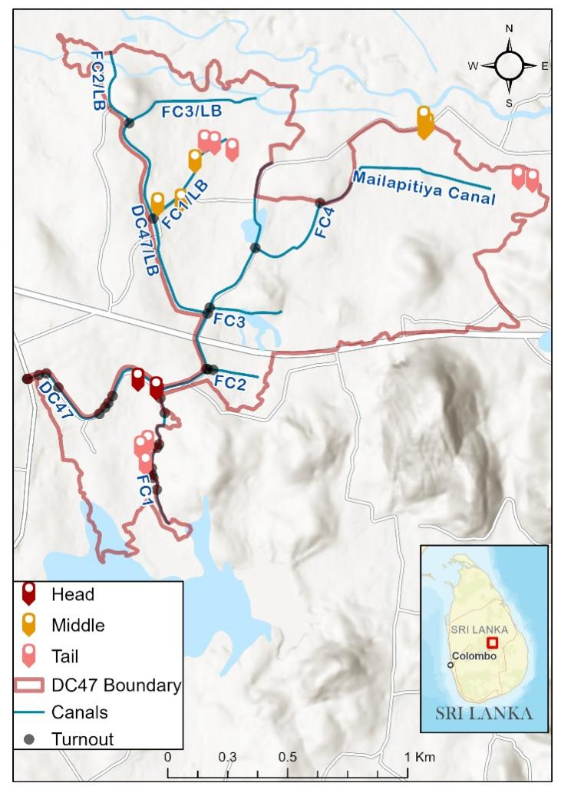
(a) Minipe left bank canal
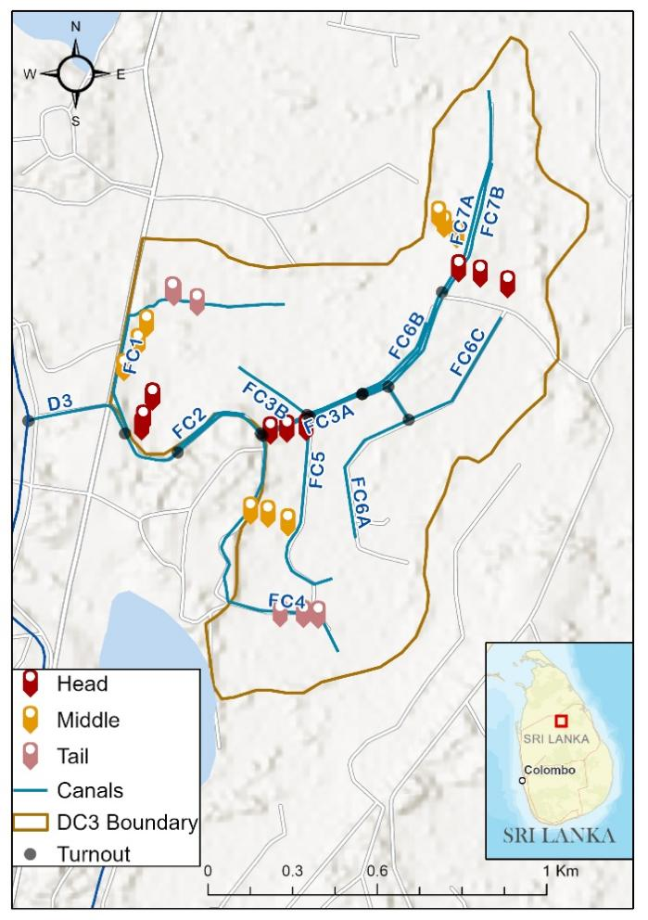
(b) Hurulu Wewa
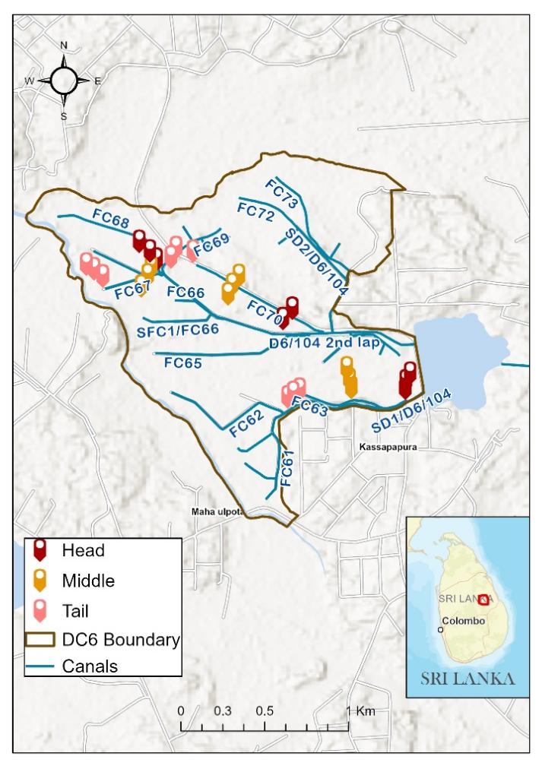
(c) Maduru Oya PDA
Fig. 1 Study area
图1 研究区域

2.1.1 Maduru Oya PDA
Part I of the present study was conducted in the command area of Mahaweli System B, Dimbulagala block, Wajira Wewa D6/104,7° 51' 59.99" N; 81° 06' 60.00" E, in the Polonnaruwa district, Sri Lanka. Maduru Oya System, also known as System B, is located in the Polonnaruwa and Batticaloa Administrative Districts of Sri Lanka with a gross land cover of 94,225 hm². Around 32,545 families live in this area comprising 19,254 farming households and 13,291 non-farming households with a total population of 125,184. The proposed area to be developed under System B is 40,065 hm² while the area developed for paddy is approximately 19,776hm² which is cultivated annually during both cultivation seasons: Yala and Maha ^{[24]}. The main water sources for System B are Maduru Oya Left Bank Main Canal (LBMC) and Pimburaththewa Main Canal which is augmented with Mahaweli water diversions. System B consists of 8 Irrigation Blocks which are provided with surface canals inclusive of field canals providing turnouts for each 1 hm² allotment. The canals selected for studies on infiltration rates were FC 67/D6/104, FC 70/D6/104 and FC63/SD1/D6/104 of Dimbulagala block. The farm lots were selected on locations at head, middle and tail areas which consist of different field and soil conditions.

2.1.2 Hurulu Wewa
Part II of the present study was conducted in the command area of Hurulu Wewa Irrigation System LB Canal D3, 8° 13’ 0” N”; 80° 43’ 0” E “, which is located in Galenbinduna Wewa Divisional Secretary Division in the Anuradhapura District, of North Central Province of Sri Lanka. The active storage capacity of Hurulu Wewa reservoir is 65.4 MCM (Million Cubic Meters) and the total designed irrigable service area is 4,209 hm² ^{[25-26]}.
The Left Bank Main Canal consists of 9 distributary canals and 21 field canals while Right Bank Main Canal consists of 2 branch canals, 8 distributary canals, and 25 field canals. Infiltration studies were conducted in three locations along D3/LB to represent the head, middle, and tail end of the canal, namely, FC 1/D3, FC4/D3, and FC7/D3.

2.1.3 Minipe Left Bank Canal
Part III of the present study was conducted in the command area of Minipe Irrigation System - LB Canal D 47 in Stage III 7° 32’ 12.794” N; 80° 54’ 46.797” E, belonging to Matale district, Sri Lanka. The study area is located in the Hettipola Divisional Secretariat of the Matale District of Central Province ^{[27]}. The infiltration studies were conducted in FC1/D47, FC1/D47/LB and Mailapitiya canals at different time intervals to determine the infiltration rates. As same as the above two areas, head, middle, and tail sections were selected to capture the variations in field and soil conditions.

2.2 Data Collection
In this study, infiltration was measured at 61 farm-lot points nested within 23 canal reaches, designated head, middle and tail, of eight field canals distributed across the three irrigation schemes (Fig. 1(a)-(c)), which ensured adequate spatial coverage of each command area. Two to three farm-lot points were measured within each canal reach, and the reach-averaged infiltration curve was used for model fitting, giving 23 curves for the comparative model evaluation. Field inspections were conducted to select suitable canals for study, to assess field conditions and determine the equipment required to measure infiltration depths and identify suitable locations, and to analyse the impacts of waterlogging in the study area. All measurements were taken during the land preparation stage of the Maha season, which is considered the standard operational period for assessing infiltration in Sri Lankan paddy systems. The tests were conducted at different intervals: in September 2021 for the Minipe canal, in September and October 2021 for the Maduru Oya PDA, and in February 2022 for Hurulu Wewa. Although the field testing at Hurulu Wewa was postponed due to delays in water release for the Maha season, caused by the non-availability of fertilizer, measurements were taken under hydrologically comparable conditions. Accordingly, tests were done only in a few selected paddy fields under the canals of PDAs. During data acquisition, factors such as high flow turbidity, irregular channel sections, sedimentation, and vegetation affecting paddy growth affected the results for some paddy fields in the infiltration depth measurements. As a result, some points at the head, middle, and tail of these canals were omitted, and locations free of obstacles during depth measurements were used in the analysis; of the 27 canal reaches originally planned (three reaches in each of three field canals in each of three schemes), 23 yielded complete infiltration curves suitable for model fitting.

2.2.1 Identification of on-site locations
On-site coordinates of watercourses and reference points were collected using the Global Positioning System (GPS). Subsequently, the collected coordinates were validated through Google Earth Pro Software (https://www.google.com/earth/). Finally, the validated images were converted into digital data and the spatial distribution was mapped using ArcGIS software.

2.2.2 Classification of soil
Because there were no high-resolution soil maps at the pilot level, the soil survey was conducted manually. A stratified field-based sampling approach was adopted rather than random sampling. Sampling locations were selected to represent the top, middle, and bottom reaches of each canal system, thereby capturing spatial variability in hydraulic loading, sediment deposition, and water residence time within each irrigation command area. Soil sampling was conducted using Dutch soil augers ^{[28]}, and in situ soils were classified according to the textural characteristics shown in the USDA soil texture triangle ^{[24]}. Textural classes were therefore assigned by field augering and tactile assessment rather than by laboratory particle-size analysis, and the compound descriptors used in Table 3 (clayey gravel, gravelly clay, clayey sand, gravelly sand) denote profiles in which a gravel or sand fraction was present in addition to the dominant textural class; they are field descriptors rather than formal USDA textural classes. Subsequently, the sampling locations were geotagged. This soil survey was conducted immediately after harvesting, when the fields were free of weeds, and the soil was in a suitable semi-dry state for augering.
2.2.3 Measuring infiltration
As a crucial parameter for understanding water movement within soil profiles, infiltration rates were assessed. The infiltration rate is influenced by various factors such as pore size distribution, soil texture, and structure ^{[5]}. These factors affect the water movement through the soil. The double-ring infiltrometer test ^{[29]} was used to determine the infiltration rates. A double-ring infiltrometer test was conducted using PVC pipes fabricated according to standard dimensions, using two PVC (Polyvinyl chloride) pipes of 0.3 meters and 0.15 meters in diameter, each approximately 0.5 meters in length. The scales were marked on both tubes. First, the 0.3-meter diameter PVC pipe was hammered vertically into the ground and leveled using a spirit level (refer to Fig. 2(a)). Then, the 0.15-meter diameter PVC pipe was placed centrally within the 0.3-meter diameter pipe and hammered similarly (around 0.1 meter into the soil layer). After that, water was filled into the space between the inner and outer rings. The water within the space between the two pipes prevented lateral water movement from the inner ring. Further, the water level was maintained at the same depth inside and outside the rings. The initial water level of the inner ring was recorded, and subsequent measurements were taken at regular intervals and the test continued until the water level drop remained consistent over equal time intervals. Paddy fields under the three canals were selected considering the upper, intermediate, and lower points of the field, whereas the head, middle, and tail were considered in each field to ensure that these selections covered the whole PDA (refer to Fig. 2(b)) and to obtain more accurate results. In total, 61 infiltration tests were carried out at different time intervals covering all three schemes selected. Measurements were continued until a near steady-state infiltration condition was reached. Water level reductions were recorded at 30-minute intervals for up to 120 minutes, with greater attention paid during the initial stage as infiltration rates changed more rapidly. Due to field-scale constraints, repeat measurements at the same point were limited; however, consistency in infiltration trends and stable readings across the 61 sampling points ensured the reliability of the dataset. Evaporation losses were not separately considered during infiltration measurements because the experiments were conducted under uniformly saturated paddy-field conditions, with continuous impoundment during land preparation. Under such conditions, evaporation effects within the infiltration rings and surrounding plots are assumed to be spatially uniform and therefore do not bias relative infiltration estimates. Measurements were of short duration and aimed at capturing in situ infiltration behaviour under saturated conditions rather than at absolute water-balance components.
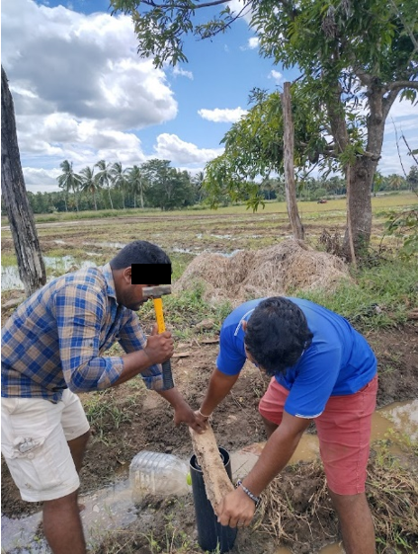  (a) Hammering PVC pipes into the ground | 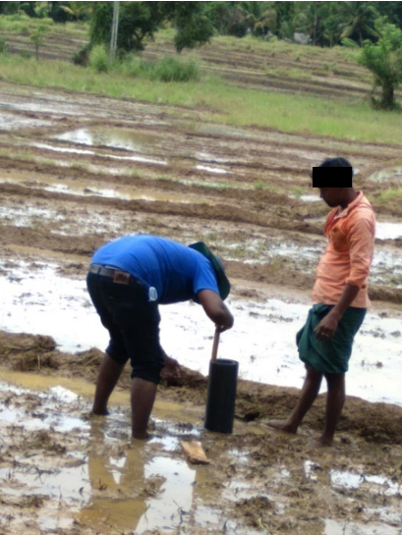  (b) Measuring infiltrated depth in FC1/D47 Minipe LB Canal
Fig. 2 Field measurement of infiltration
图2 地下水入渗现场测量
2.3 Methodology
The infiltration rates were calculated using the depths measured at different time intervals, and these values were compared with the simulated values obtained from GREEN-AMPT’s, KOSTIAKOV’s, HORTON’s, and PHILIP’s models for all locations. Then, performance evaluation and comparison were then carried out using the parameters specific to each model.

2.3.1 Infiltration Models
This study used four different models: GREEN-AMPT’s ^{[7]}, KOSTIAKOV’s ^{[15]}, HORTON’s ^{[11]}, and PHILIP’s ^{[8]} to simulate the infiltration capacity and parameters.

2.3.1.1 GREEN-AMPT’s Model
GREEN and AMPT directly applied Darcy's law and proposed a simple model for water infiltration into homogenous soil^{[7]}. The model is expressed by Eq. (1).

$${\text{f}}_{\text{p}}\text{=}\text{m}\text{+}\text{n}\text{/}{\text{F}}_{\text{p}}$$ | (1)
where ${\text{F}}_{\text{p}}$ is the infiltration capacity (cm) and ${\text{f}}_{\text{p}}$ is the infiltration rate (cm/h) at any given time t (h); $\text{m}$ (cm/h) and $\text{n}$ (cm²/h) are GREEN-AMPT’s parameters of the infiltration model.

2.3.1.2 KOSTIAKOV’s Model
KOSTIAKOV proposed an equation to estimate the infiltration rate over time^{[15]}. This empirical model provides the cumulative infiltration through Eq. (2).

$${\text{F}}_{\text{p}}\text{=}\text{a}{\text{t}}^{\text{b}}$$ | (2)

where ${\text{F}}_{\text{p}}$ is the infiltration capacity (cm) at any given time $\text{t}$ from the start; $\text{t}$ = time from the start of infiltration (h); $\text{a}$ and $\text{b}$ are unitless constants that depend on the soil's initial conditions with $\text{a}\text{>0}$ and $\text{0<}\text{b}\text{<1}$.

2.3.1.3 HORTON’s model
HORTON ^{[11]} noticed that the decrease in infiltration capacity over time is directly related to the infiltration rate. As a result, a semi-empirical model was expressed as the decay of infiltration capacity with time as an exponential decay. It is given by Eq. (3).

$${\text{f}}_{\text{p}}\text{=}{\text{f}}_{\text{c}}\text{+(}{\text{f}}_{\text{0}}\text{-}{\text{f}}_{\text{c}}\text{)}{{\text{e}}^{{\text{k}}_{\text{h}}}}^{\text{t}}$$ | (3)

where ${\text{f}}_{\text{p}}$ is the infiltration rate (cm/h) at time $\text{t}$ from the start; ${\text{f}}_{\text{0}}$ is the initial infiltration rate at time $\text{t}\text{=0}$; ${\text{f}}_{\text{c}}$= final infiltration rate (cm/h) occurring at $\text{t}\text{=}{\text{t}}_{\text{c}}$ (hr); ${\text{k}}_{\text{h}}$ is the HORTON’s decay coefficient (min⁻¹).

2.3.1.4 PHILIP’s Model
PHILIP ^{[8]} proposed a method to establish a connection between cumulative infiltration and soil characteristics. This physical-based model expresses infiltration rate in Eq. (4).

$$\text{F}\text{=}\text{s}{\text{t}}^{\text{0.5 }}\text{+}\text{Kt}$$ | (4)

Differentiating Eq. (4), the infiltration capacity is expressed as Eq. (5).
$$\text{f}\text{=}\frac{\text{1}}{\text{2}}\text{s}{\text{t}}^{\text{-0.5 }}\text{+}\text{K}$$ | (5)
where $\text{f}$ is the infiltration rate at any time $\text{t}$ from the start (cm/h); $\text{s}$ is the soil suction potential function known as sorptivity (cm/h^{0.5}); $\text{k}$ is the Darcy’s hydraulic conductivity (cm/h).

2.3.2 Statistical analysis of infiltration rates using different performance indices
2.3.2.1 Correlation coefficient (r)
The coefficient of correlation is a statistical measure that calculates the strength of the relationship between the relative movements of two variables. The coefficient of correlation is calculated as given in the Eq. (6).

$$\text{r}\text{=}\frac{\sum{\text{(}{\text{x}}_{\text{i}}\text{-}\overline{\text{x}}\text{)(}{\text{y}}_{\text{i}}\text{-}\overline{\text{y}}\text{)}}}{\sqrt{\sum{{\text{(}{\text{x}}_{\text{i}}\text{-}\overline{\text{x}}\text{)}}^{\text{2 }}}\sum{{\text{(}{\text{x}}_{\text{i}}\text{-}\overline{\text{x}}\text{)}}^{\text{2 }}}}}$$ | (6)

where, ${\text{x}}_{\text{i}}$ are the values of observed data $\overline{\text{x}}$ are the mean of the values of observed data; ${\text{y}}_{\text{i}}$ are the values of estimated data and $\overline{\text{y}}$ are the mean of the values of the estimated data.

2.3.2.2 Root Mean Square Error (RMSE)
The root mean square error quantifies the average magnitude of the error between simulated and observed values. This is evaluated as given in Eq. (7).
$$\text{RMSE}\text{=}\sqrt{\frac{\text{1}}{\text{N}}\left({\sum_{\text{i}\text{=1}}^{\text{n}}{{\text{(}\text{x}}_{\text{i}}}\text{-}{\text{y}}_{\text{i}}\text{)}}^{\text{2}}\right)}$$ | (7)
where ${\text{x}}_{\text{i}}$ are the values of the observed value; ${\text{y}}_{\text{i}}$are the values of the estimated value; ${\text{x}}_{\text{i}}$ is the number of observations.

2.3.2.3 Nash-Sutcliffe Efficiency (NSE)
The Nash-Sutcliffe efficiency can be used as a method to compare the performance of hydrological modeling when there are two variables. The mathematical formulation is given in Eq. (8).
$$\text{NSE}\text{=1-}\frac{{\sum_{\text{i}\text{=1}}^{\text{n}}{{\text{(}\text{x}}_{\text{i}}}\text{-}{\text{y}}_{\text{i}}\text{)}}^{\text{2}}}{{\sum_{\text{i}\text{=1}}^{\text{n}}{{\text{(}\text{x}}_{\text{i}}}\text{-}\overline{\text{x}}\text{)}}^{\text{2}}}$$ | (8)

where ${\text{x}}_{\text{i}}$ are the values of the observed data; $\overline{\text{x}}$ are the mean of the values of the observed data; ${\text{y}}_{\text{i}}$ are the values of the estimated data in $\text{n}$ number of observations.
The recommended ranges of the different performance indices that are frequently used in practice are given in Table 1.

Table 1 Recommended ranges of different performance indices ^{[30]}
表1 不同性能指标的推荐范围^{[30]}
Performance rating | $$\text{r}$$ | $$\text{NSE}$$ | $$\text{RMSE}$$
Very Good | 0.8-1 | 0.75-1 | <0.05
Good | 0.6-0.8 | 0.65-0.75 | 0.05-0.1
Satisfactory | 0.4-0.6 | 0.5-0.65 | 0.1-0.2
Unsatisfactory | <0.4 | <0.5 | <0.2

2.3.4 Overall methodology
Fig. 3 presents the flowchart for the overall methodology carried out in this research work.
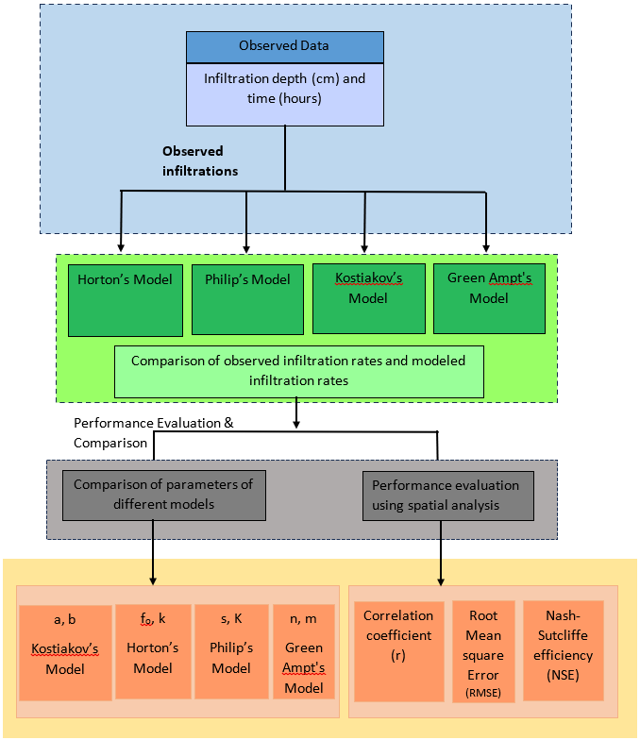
Fig. 3 Overall methodology
图3 技术路线
3. Results and Discussion
Table 2 presents the saturated infiltration rates for selected locations in the study, and Table 3 lists the complete set of results. The measured infiltration rates ranged from 0.11 cm/h to 0.96 cm/h across the 61 farm-lot points. All three study areas were dominated by clay-textured profiles, as determined by field augering and the USDA soil texture triangle. Soils with a higher sand or gravel fraction exhibited higher infiltration rates than the clay-dominated profiles. The highest rate, 0.96 cm/h, was recorded in Minipe D47 (FC1/D47 LB) and the lowest, 0.11 cm/h, in Hurulu Wewa (FC4/D3). At Hurulu Wewa the rates ranged from 0.11 cm/h to 0.40 cm/h, reflecting the high clay content of that command area. A rate of 0.85 cm/h was observed in the Mailapitiya canal, where the field canal traverses gravelly clay, and 0.60 cm/h in Minipe D47 (FC1/D47) where the profile is sandy clay. Although the dominant texture was clay in all three main field canals, infiltration rates were consistently higher where gravel and sand fractions were present. Scheme means were 0.504 cm/h at Minipe D47, 0.383 cm/h at Maduru Oya PDA and 0.223 cm/h at Hurulu Wewa, and the between-scheme differences were highly significant (KRUSKAL-WALLIS, p < 0.001). A hydrological study at the University of Cape Coast School of Agriculture Research Station at Twifo Wamaso, Ghana, showed that the hydraulic conductivity of sandy soil is higher than that of clayey soil, because water moves more quickly through the large pore spaces between coarse particles than through fine pores ^{[31]}. Clayey soils containing gravel therefore exhibit higher infiltration rates than clay alone. Residual variation is attributable to soil texture, faunal burrowing, incomplete prewetting, and soil disturbance caused by driving the infiltration rings.
Table 2 Infiltration rates at saturation in some field canals in the study area
表2 研究区域内某些田间渠道的饱和渗透速率
Field Canal | Farm Lot Location | Infiltration rates /cm·h⁻¹
FC 1/D47 | Head lower end | 0.3
FC1/D47 LB | Intermediate | 0.34
FC1/D47 LB | Intermediate | 0.96
Mailapitiya Canal | Intermediate | 0.85
Mailapitiya Canal | Tail end | 0.39
Mailapitiya Canal | Tail Intermediate | 0.32
Mailapitiya Canal | Tail Lower end | 0.48
FC 70/D6/104 | Middle Lower end | 0.45
FC 70/D6/104 | Tail Upper end | 0.33
FC63/SD1/D6/104 | Head Upper end | 0.19
FC63/SD1/D6/104 | Middle Lower end | 0.49
FC 1/D3 | Tail end | 0.25
FC 1/D3 | Middle Tail end | 0.12
FC4/D3 | Head Upper end | 0.11
FC4/D3 | Tail Intermediate | 0.31
FC7/D3 | Head Tail end | 0.12
FC7/D3 | Middle Upper end | 0.38
Table 3 Infiltration rates at saturation in different field canals in the study area
表3 研究区不同田间渠道饱和时的渗透速率
Field Canal |  | Canal Area | Farm Lot Location | Soil Type | Infiltration rate /cm·h⁻¹
Minipe D47 | FC 1/D47 | Head End | Upper end | Clayey gravel | 0.31
Minipe D47 | FC 1/D47 | Head End | Lower end | Clayey gravel | 0.30
Minipe D47 | FC 1/D47 | Tail End | Upper end | Sandy clay | 0.53
Minipe D47 | FC 1/D47 | Tail End | Intermediate | Sandy clay | 0.42
Minipe D47 | FC 1/D47 | Tail End | Tail end | Sandy clay | 0.60
Minipe D47 | FC1/D47 LB | Middle | Upper end | Sandy clay | 0.53
Minipe D47 | FC1/D47 LB | Middle | Intermediate | Clay | 0.34
Minipe D47 | FC1/D47 LB | Middle | Tail end | Clay | 0.51
Minipe D47 | FC1/D47 LB | Tail End | Upper end | Gravelly clay | 0.44
Minipe D47 | FC1/D47 LB | Tail End | Intermediate | Gravelly clay | 0.96
Minipe D47 | FC1/D47 LB | Tail End | Tail end | Sandy clay | 0.35
Minipe D47 | Mailapitiya Canal | Middle | Intermediate | Gravelly clay | 0.85
Minipe D47 | Mailapitiya Canal | Middle | Tail end | Clay (high clay content) | 0.39
Minipe D47 | Mailapitiya Canal | Tail End | Upper end | Sandy clay | 0.46
Minipe D47 | Mailapitiya Canal | Tail End | Intermediate | Sandy clay | 0.46
Minipe D47 | Mailapitiya Canal | Tail End | Tail end | Sandy clay | 0.62
Hurulu Wewa | FC 1/D3 | Head End | Upper end | Clay | 0.24
Hurulu Wewa | FC 1/D3 | Head End | Intermediate | Clay | 0.17
Hurulu Wewa | FC 1/D3 | Head End | Tail end | Clay | 0.25
Hurulu Wewa | FC 1/D3 | Middle | Upper end | Clay (high clay content) | 0.19
Hurulu Wewa | FC 1/D3 | Middle | Intermediate | Clay (high clay content) | 0.15
Hurulu Wewa | FC 1/D3 | Middle | Tail end | Clay (high clay content) | 0.12
Hurulu Wewa | FC 1/D3 | Tail End | Upper end | Clay (high clay content) | 0.17
Hurulu Wewa | FC 1/D3 | Tail End | Intermediate | Clay (high clay content) | 0.15
Hurulu Wewa | FC4/D3 | Head End | Upper end | Clay | 0.11
Hurulu Wewa | FC4/D3 | Head End | Intermediate | Clay | 0.29
Hurulu Wewa | FC4/D3 | Head End | Tail end | Clay | 0.18
Hurulu Wewa | FC4/D3 | Middle | Upper end | Clay (high clay content) | 0.14
Hurulu Wewa | FC4/D3 | Middle | Intermediate | Clay (high clay content) | 0.32
Hurulu Wewa | FC4/D3 | Middle | Tail end | Clay (high clay content) | 0.27
Hurulu Wewa | FC4/D3 | Tail End | Upper end | Clay (high clay content) | 0.27
Hurulu Wewa | FC4/D3 | Tail End | Intermediate | Clay (high clay content) | 0.31
Hurulu Wewa | FC4/D3 | Tail End | Tail end | Clay (high clay content) | 0.15
Hurulu Wewa | FC7/D3 | Head End | Upper end | Clay | 0.30
Hurulu Wewa | FC7/D3 | Head End | Tail end | Clay | 0.12
Hurulu Wewa | FC7/D3 | Middle | Upper end | Clay | 0.38
Hurulu Wewa | FC7/D3 | Middle | Intermediate | Clay | 0.40
Hurulu Wewa | FC7/D3 | Middle | Tail end | Clay | 0.22
Maduru Oya PDA | FC 67/D6/104 | Head End | Upper end | Sandy clay | 0.39
Maduru Oya PDA | FC 67/D6/104 | Head End | Intermediate | Clay | 0.48
Maduru Oya PDA | FC 67/D6/104 | Head End | Lower end | Clay (high clay content) | 0.41
Maduru Oya PDA | FC 67/D6/104 | Middle | Upper end | Sandy clay | 0.37
Maduru Oya PDA | FC 67/D6/104 | Middle | Intermediate | Clay | 0.43
Maduru Oya PDA | FC 67/D6/104 | Middle | Lower end | Clay (high clay content) | 0.41
Maduru Oya PDA | FC 67/D6/104 | Tail End | Upper end | Clayey sand | 0.40
Maduru Oya PDA | FC 67/D6/104 | Tail End | Intermediate | Clay | 0.32
Maduru Oya PDA | FC 67/D6/104 | Tail End | Lower end | Clay (high clay content) | 0.48
Maduru Oya PDA | FC 70/D6/104 | Head End | Intermediate | Gravelly clay | 0.34
Maduru Oya PDA | FC 70/D6/104 | Head End | Lower end | Clay (high clay content) | 0.43
Maduru Oya PDA | FC 70/D6/104 | Middle | Upper end | Gravelly sand | 0.40
Maduru Oya PDA | FC 70/D6/104 | Middle | Intermediate | Gravelly sand | 0.35
Maduru Oya PDA | FC 70/D6/104 | Middle | Lower end | Clay (high clay content) | 0.45
Maduru Oya PDA | FC 70/D6/104 | Tail End | Upper end | Gravelly clay | 0.33
Maduru Oya PDA | FC 70/D6/104 | Tail End | Intermediate | Clayey gravel | 0.36
Maduru Oya PDA | FC 70/D6/104 | Tail End | Lower end | Clayey gravel | 0.44
Maduru Oya PDA | FC63/SD1/D6/104 | Head End | Upper end | Clay | 0.19
Maduru Oya PDA | FC63/SD1/D6/104 | Head End | Intermediate | Clay | 0.28
Maduru Oya PDA | FC63/SD1/D6/104 | Head End | Tail end | Clay | 0.38
Maduru Oya PDA | FC63/SD1/D6/104 | Middle | Upper end | Clay | 0.38
Maduru Oya PDA | FC63/SD1/D6/104 | Middle | Lower end | Clay | 0.49
Maduru Oya PDA | FC63/SD1/D6/104 | Tail End | Lower end | Clay | 0.31
Note: Textural descriptors were assigned in the field by augering and tactile assessment following the USDA soil texture triangle ^{[28]}. The compound descriptors clayey gravel, gravelly clay, clayey sand and gravelly sand denote profiles in which a gravel or sand fraction was present in addition to the dominant textural class; they are field descriptors rather than formal USDA textural classes. Laboratory particle-size analysis was not performed.
The parameters of the four equations determined by the line of best fit from the statistical analysis for the Minipe D 47 field canal are summarized in Fig. 4 (a)-(i). The values of each parameter were determined for all 61 farm-lot points (Fig. 5 for all other results). The fitted values of KOSTIAKOV’s parameter b ranged between 0.131 and 1.205, with 58 of the 61 values (95%) below unity, which is broadly consistent with infiltration theory, which requires b to be positive and less than unity; the three values marginally exceeding unity occurred at points where the measured curve was still declining at the end of the 2 h test window ^{[4]}. The sorptivity obtained from PHILIP’s model averaged 0.374 cm/h^{0.5} compliance with the $\text{s}$ value estimated in alluvial clay as 0.5 cm/h^{0.5} ^{[32-33]} and values observed in silt and loam between 0.35 cm/h^{0.5} and 0.4 cm/h^{0.5 [25]}. In addition, the hydraulic conductivity (K) was highest (0.463 cm/h) in Minipe D47 which contains sandy clay, and minimum as 0.011 cm/h was recorded in the Maduru Oya PDA (FC 70/D6/104) which has highly clay soil by confirming that $\text{K}$ value reduces from gravelly soil to clayey soil ^{[34]}. Further, ${\text{K}}_{\text{h}}$ was shown as 3.730 min⁻¹ to 3.730 min⁻¹. These values are reliable as per the range ${\text{K}}_{\text{h}}$ value range observed in clayey soil by PITT et al. ^{[35]}. Moreover, initial infiltration exceeded final infiltration at 56 of the 61 points according to the results of HORTON’s model as demonstrated by HORTON ^{[36]}. Initially, infiltration occurs rapidly because the soil is unsaturated and the matric potential gradient is steep; over time the rate decreases as the profile wets up, approaching a lower steady value. At the five remaining points the fitted initial rate did not exceed the fitted final rate, a combination that is physically inadmissible in HORTON’s formulation and which arises where the observed curve had not yet flattened within the measurement window.
(a) HORTON's model parameter, kh
(b) HORTON's model parameter, fo
(c) HORTON's model parameter, fc
(d) PHILIP's model parameter, K
(e) PHILIP's model parameter, S
(f) KOSTIAKOV's model parameter, a
(g) KOSTIAKOV's model parameter, b
(h) GREEN-AMPT's model parameter, n
(i) GREEN-AMPT's model parameter, m
Fig. 4 Fitted infiltration model parameters for Minipe D47
图4 Minipe D47的拟合入渗模型参数
(a) HORTON's model parameter, kh, Hurulu Wewa LB D3
(b) HORTON's model parameter, fo, Hurulu Wewa LB D3
(c) HORTON's model parameter, fc, Hurulu Wewa LB D3
(d) PHILIP's model parameter, S, Hurulu Wewa LB D3
(e) PHILIP's model parameter, K, Hurulu Wewa LB D3
(f) KOSTIAKOV's model parameter, a, Hurulu Wewa LB D3
(g) KOSTIAKOV's model parameter, b, Hurulu Wewa LB D3
(h) GREEN-AMPT's model parameter, n, Hurulu Wewa LB D3
(i) GREEN-AMPT's model parameter, m, Hurulu Wewa LB D3
(j) Horton's model parameter, kh, Maduru Oya PDA
(k) HORTON's model parameter, fo, Maduru Oya PDA
(l) HORTON's model parameter, fc, Maduru Oya PDA
(m) PHILIP's model parameter, S, Maduru Oya PDA
(n) PHILIP's model parameter, K, Maduru Oya PDA
(o) KOSTIAKOV's model parameter, a, Maduru Oya PDA
(p) KOSTIAKOV's model parameter, b, Maduru Oya PDA
(q) GREEN-AMPT's model parameter, n, Maduru Oya PDA
(r) GREEN-AMPT's model parameter, m, Maduru Oya PDA
Fig. 5 Fitted infiltration model parameters for Hurulu Wewa LB D3, and Maduru Oya PDA
图5 Hurulu-Wewa LB D3和Maduru-Oya PDA的拟合入渗模型参数
To interpret these parameters physically, the PHILIP parameters were cross-tabulated against the field textural classes reported in Table 3 and against canal position (Table 4). Both sorptivity and hydraulic conductivity increased systematically as the coarse fraction of the profile increased. Textural classes containing an appreciable gravel or sand fraction (gravelly clay, sandy clay, clayey gravel, clayey sand and gravelly sand; n = 22) gave a mean K of 0.223 ± 0.137 cm/h and a mean S of 0.458 ± 0.405 cm/h^{0.5}, whereas the clay-dominated classes (n = 39) gave 0.165 ± 0.153 cm/h and 0.326 ± 0.255 cm/h^{0.5}. The highest class-mean values of both parameters occurred in the gravelly clay of Minipe D47 (S = 0.660 cm/h^{0.5}, K = 0.242 cm/h), and the lowest conductivity in the high-clay profiles of Hurulu Wewa LB D3 (K = 0.136 cm/h). Across all 61 points, both parameters correlated significantly with the measured steady infiltration rate (S: r = 0.51, p < 0.001; K: r = 0.43, p < 0.001), which confirms that the fitted PHILIP parameters carry genuine textural information rather than being numerical artefacts of curve fitting. The contrast in K between the two textural groups was, however, only marginally significant (Mann-Whitney U, p = 0.066), reflecting both the unbalanced group sizes and the limited resolution of field-based textural assessment, whereas the corresponding contrast in measured infiltration rate was highly significant (p < 0.001). The single anomaly in Table 4 is the clayey gravel class (n = 4), which combines a high mean sorptivity with the lowest mean conductivity of any class; these four points comprise two at the head reach of Minipe D47 and two at the tail reach of Maduru Oya, where surface siltation appears to have created a thin, highly absorptive but poorly transmitting surface layer over a gravelly subsoil.
Table 4 PHILIP model parameters (S, K) and measured infiltration rate grouped by field textural class, canal reach and irrigation scheme (n = 61 farm-lot points)
表4 PHILIP模型参数（S，K）和按田间质地等级、渠道河段和灌溉方案分组的实测入渗率（n=61个农场地块点）
Grouping | Class | n | S /cm·h^{-0.5} | K /cm·h⁻¹ | Measured f /cm·h⁻¹ | Median t_{grav} /h
Textural class | Gravelly sand | 2 | 0.042 ± 0.027 | 0.298 ± 0.075 | 0.375 ± 0.035 | 0.03
Textural class | Clayey sand | 1 | 0.199 | 0.279 | 0.400 | 0.51
Textural class | Sandy clay | 10 | 0.452 ± 0.145 | 0.243 ± 0.122 | 0.473 ± 0.094 | 3.06
Textural class | Gravelly clay | 5 | 0.660 ± 0.730 | 0.242 ± 0.186 | 0.584 ± 0.299 | 2.12
Textural class | Clay | 22 | 0.327 ± 0.291 | 0.187 ± 0.174 | 0.308 ± 0.116 | 4.80
Textural class | Clay (high clay content) | 17 | 0.325 ± 0.206 | 0.136 ± 0.120 | 0.283 ± 0.126 | 8.76
Textural class | Clayey gravel | 4 | 0.493 ± 0.405 | 0.099 ± 0.107 | 0.352 ± 0.064 | 316.07
Canal reach | Head end | 18 | 0.277 ± 0.166 | 0.138 ± 0.076 | 0.287 ± 0.107 | —
Canal reach | Middle | 22 | 0.420 ± 0.446 | 0.222 ± 0.187 | 0.368 ± 0.160 | —
Canal reach | Tail end | 21 | 0.408 ± 0.250 | 0.190 ± 0.147 | 0.406 ± 0.182 | —
Scheme | Minipe D47 | 16 | 0.490 ± 0.430 | 0.263 ± 0.128 | 0.504 ± 0.184 | —
Scheme | Maduru Oya PDA | 23 | 0.367 ± 0.324 | 0.196 ± 0.179 | 0.383 ± 0.070 | —
Scheme | Hurulu Wewa | 22 | 0.295 ± 0.184 | 0.120 ± 0.095 | 0.223 ± 0.086 | —
Along the canal, the measured infiltration rate increased from the head reaches (0.287 ± 0.107 cm/h) through the middle (0.368 ± 0.160 cm/h) to the tail reaches (0.406 ± 0.182 cm/h), and this gradient was statistically significant (KRUSKAL-WALLIS, p = 0.043). The corresponding gradients in S and K were of the same sign but were not statistically resolvable (p = 0.29 and p = 0.56, respectively). The most probable cause is progressive deposition of fine suspended sediment in the head reaches, where canal water first enters the command area and flow velocities fall sharply; the resulting surface siltation reduces the effective conducting porosity without necessarily altering the bulk textural class recorded by augering. Between schemes the difference in K was significant (KRUSKAL-WALLIS, p = 0.008), with Hurulu Wewa clearly separated from the other two schemes (p = 0.017), consistent with its uniformly high clay content. It must be stated explicitly that antecedent volumetric moisture content was not measured in this study. All tests were performed during land preparation under ponded, near-saturated conditions, so between-point variability in antecedent moisture is expected to be small relative to the textural signal; nevertheless, the absence of measured initial moisture is a limitation, and the values of S reported here should be read as effective near-saturated sorptivities rather than as sorptivities referenced to a defined initial water content.
A further physical result emerges from the ratio of the two PHILIP parameters. The characteristic time at which gravity begins to dominate capillarity, t_{grav} = (S/K)², had a median value of 5.63 h across the 61 points and exceeded the 2 h duration of the infiltration test at 35 of them (57%). The double-ring measurements therefore sampled predominantly the capillary-dominated, early-time limb of the infiltration curve, in which cumulative infiltration is governed by the S t0.5 term. This is precisely the regime that the PHILIP series was derived to represent, and it explains both why the PHILIP and GREEN-AMPT formulations reproduced the observations so closely and why HORTON's model performed least well: HORTON's formulation presumes an exponential approach to a genuinely attained steady-state rate fc, whereas at most points a true steady state had not been reached within the measurement window. The same reasoning accounts for the five points at which the fitted fo did not exceed fc. Notably, tgrav was shortest in the sand-bearing classes (class medians 0.03-3.06 h for gravelly sand, clayey sand, gravelly clay and sandy clay) and longest in the clay-dominated classes (4.80 and 8.76 h), the only exception being the four clayey gravel points discussed above. The advantage of the capillarity-explicit PHILIP formulation is therefore expected to be greatest in exactly the heavy-clay profiles that dominate Sri Lankan paddy command areas.
Because the evaluated infiltration models are deterministic, formal significance testing of model differences was not performed. The best-fit model was selected based on the results in Table 5: a Maximum coefficient of correlation (R²), a minimum Root Mean Square Error (RMSE), and a maximum Nash-Sutcliffe efficiency (NSE). In this statistical evaluation, all 23 canal reaches were used with each performance indicator. Comparing the simulated and measured infiltration rates at saturation, the average R2 and NSE values were computed for the selected four models based on the relationship identified from the scatter plots (Fig. 6). The values of the $\text{r}$ range from 0.9206 to 0.9999 and NSE from 0.8525 to 0.9999. These values indicate that the fitted models account for almost all of the variability in the calibration data. Ranked by mean performance across all three indices, the order is GREEN-AMPT's, PHILIP's, KOSTIAKOV's and HORTON's models. It must be emphasised that these indices describe the quality of fit obtained after each model's parameters had been optimised against the same measured curve; they are calibration statistics, not independent validation statistics. Near-unity R² and NSE values are therefore expected, and should be interpreted as a measure of each model's structural capacity to reproduce the observed shape of the infiltration curve rather than as evidence of predictive skill at unmeasured locations. Split-sample or leave-one-out validation was not possible because only one reach-averaged infiltration curve was obtained per canal reach; this is acknowledged as a limitation, and independent validation against withheld measurements is recommended in future work.
Table 5 Performance evaluation parameters of the different infiltration models
表5 不同入渗模型的性能评价参数
Field Canal |  | Canal Area | R² |  |  |  | RMSE |  |  |  | NSE
 |  | Canal Area | KOSTIAKOV | PHILIP | HORTON | GREEN-AMPT's | KOSTIAKOV | PHILIP | HORTON | GREEN-AMPT's | KOSTIAKOV | PHILIP | HORTON | GREEN-AMPT's
Minipe D47 | FC 1/D47 | Head End | 0.9999 | 0.9999 | 0.9999 | 0.9999 | 0.0866 | 0.0001 | 0.0965 | 0.0001 | 0.8525 | 0.9999 | 0.9674 | 0.9999
Minipe D47 | FC 1/D47 | Tail End | 0.9999 | 0.9995 | 0.9907 | 0.9989 | 0.0057 | 0.0057 | 0.3567 | 0.0023 | 0.9999 | 0.9999 | 0.9999 | 0.9999
Minipe D47 | FC1/D47 LB | Middle | 0.9994 | 0.9998 | 0.9915 | 0.9999 | 0.1852 | 0.0096 | 0.3437 | 0.0001 | 0.9994 | 0.9956 | 0.9999 | 0.9999
Minipe D47 | FC1/D47 LB | Tail End | 0.9989 | 0.9999 | 0.9559 | 0.9999 | 0.1826 | 0.0000 | 0.0960 | 0.0001 | 0.9999 | 0.9999 | 0.9129 | 0.9999
Minipe D47 | Mailapitiya Canal | Middle | 0.9999 | 0.9999 | 0.9999 | 0.9999 | 0.2208 | 0.0000 | 0.0721 | 0.0001 | 0.9341 | 0.9999 | 0.9943 | 0.9974
Minipe D47 | Mailapitiya Canal | Tail End | 0.9986 | 0.9821 | 0.9738 | 0.9937 | 0.0962 | 0.0191 | 0.0424 | 0.0242 | 0.9911 | 0.9526 | 0.9423 | 0.9979
Hurulu Wewa | FC 1/D3 | Head End | 0.9206 | 0.9999 | 0.9797 | 0.9999 | 0.2449 | 0.0001 | 0.1557 | 0.0001 | 0.9999 | 0.9999 | 0.9999 | 0.9999
Hurulu Wewa | FC 1/D3 | Middle | 0.9556 | 0.9999 | 0.9999 | 0.9999 | 0.1856 | 0.0000 | 0.0464 | 0.0001 | 0.9999 | 0.9999 | 0.9999 | 0.9999
Hurulu Wewa | FC 1/D3 | Tail End | 0.9999 | 0.9999 | 0.9999 | 0.9999 | 0.1753 | 0.0000 | 0.0328 | 0.0001 | 0.9999 | 0.9999 | 0.9999 | 0.9999
Hurulu Wewa | FC4/D3 | Head End | 0.9865 | 0.9992 | 0.9960 | 0.9999 | 0.1858 | 0.0055 | 0.1540 | 0.0001 | 0.9996 | 0.9995 | 0.9996 | 0.9999
Hurulu Wewa | FC4/D3 | Middle | 0.9960 | 0.9999 | 0.9695 | 0.9999 | 0.1656 | 0.0008 | 0.1349 | 0.0001 | 0.9999 | 0.9999 | 0.9999 | 0.9999
Hurulu Wewa | FC4/D3 | Tail End | 0.9876 | 0.9999 | 0.9835 | 0.9999 | 0.2269 | 0.0000 | 0.1338 | 0.0006 | 0.9999 | 0.9999 | 0.9999 | 0.9999
Hurulu Wewa | FC7/D3 | Head End | 0.9999 | 0.9999 | 0.9999 | 0.9999 | 0.1685 | 0.0025 | 0.1115 | 0.0001 | 0.9988 | 0.9970 | 0.9988 | 0.9999
Hurulu Wewa | FC7/D3 | Middle | 0.9684 | 0.9997 | 0.9369 | 0.9999 | 0.2052 | 0.0023 | 0.1550 | 0.0001 | 0.9989 | 0.9961 | 0.9989 | 0.9999
Maduru Oya PDA | FC 67/D6/104 | Head End | 0.9766 | 0.9999 | 0.9701 | 0.9999 | 0.0970 | 0.0000 | 0.2751 | 0.0001 | 0.9999 | 0.9999 | 0.9999 | 0.9999
Maduru Oya PDA | FC 67/D6/104 | Middle | 0.9999 | 0.9999 | 0.9801 | 0.9999 | 0.0420 | 0.0000 | 0.1637 | 0.0001 | 0.9999 | 0.9999 | 0.9999 | 0.9999
Maduru Oya PDA | FC 67/D6/104 | Tail End | 0.9972 | 0.9999 | 0.9497 | 0.9999 | 0.0792 | 0.0014 | 0.2102 | 0.0001 | 0.9999 | 0.9999 | 0.9999 | 0.9999
Maduru Oya PDA | FC 70/D6/104 | Head End | 0.9809 | 0.9999 | 0.9914 | 0.9999 | 0.1585 | 0.0049 | 0.3374 | 0.0001 | 0.9999 | 0.9999 | 0.9091 | 0.9999
Maduru Oya PDA | FC 70/D6/104 | Middle | 0.9968 | 0.9999 | 0.9679 | 0.9999 | 0.1292 | 0.0019 | 0.0973 | 0.0000 | 0.9999 | 0.9999 | 0.9619 | 0.9999
Maduru Oya PDA | FC 70/D6/104 | Tail End | 0.9999 | 0.9999 | 0.9999 | 0.9999 | 0.1230 | 0.0015 | 0.1017 | 0.0001 | 0.9999 | 0.9999 | 0.9875 | 0.9999
Maduru Oya PDA | FC63/SD1/D6/104 | Head End | 0.9999 | 0.9999 | 0.9913 | 0.9999 | 0.0599 | 0.0000 | 0.3435 | 0.0001 | 0.9816 | 0.9999 | 0.9528 | 0.9999
Maduru Oya PDA | FC63/SD1/D6/104 | Middle | 0.9999 | 0.9999 | 0.9999 | 0.9999 | 0.0316 | 0.0024 | 0.2223 | 0.0020 | 0.9947 | 0.9940 | 0.9761 | 0.9951
Maduru Oya PDA | FC63/SD1/D6/104 | Tail End | 0.9999 | 0.9999 | 0.9999 | 0.9999 | 0.0755 | 0.0000 | 0.1000 | 0.0001 | 0.9367 | 0.9999 | 0.9999 | 0.9999

According to the observed and estimated infiltration rates of the four models, HORTON's model showed the highest deviation, overestimating rates at almost all sampling points, and KOSTIAKOV's model was the next poorest. Both are empirical or semi-empirical formulations whose parameters lack a consistent physical interpretation, and the graphical procedure used to obtain the initial and steady-state rates that these models require as inputs is sensitive to reading error and, as shown above, to the fact that a true steady state was rarely attained within the test window. The two physically based models performed distinctly better. Averaged over the 23 canal reaches, GREEN-AMPT's model returned R² = 0.9996, RMSE = 0.0013 cm/h and NSE = 0.9995, and PHILIP's model returned R² = 0.9991, RMSE = 0.0025 cm/h and NSE = 0.9971, against R² = 0.9897, RMSE = 0.1361 cm/h and NSE = 0.9864 for KOSTIAKOV's model and R² = 0.9838, RMSE = 0.1645 cm/h and NSE = 0.9826 for HORTON's. The difference between the two physically based models is not meaningful: PHILIP's model gave the lower RMSE at 10 of the 23 reaches, GREEN-AMPT's at 11, and the two were identical at the remaining 2. GREEN-AMPT's model was marginally the more robust in the worst case (minimum R² = 0.9937, minimum NSE = 0.9951) compared with PHILIP's model (0.9821 and 0.9526). The defensible conclusion is therefore that the physically based GREEN-AMPT and PHILIP models are statistically indistinguishable from one another under these conditions, and that both clearly outperform the empirical KOSTIAKOV and semi-empirical HORTON models. PHILIP's model is nonetheless preferred for practical application in these schemes, because its two parameters S and K are directly interpretable in terms of measurable soil hydraulic properties and vary systematically with soil texture (Table 5), whereas the m and n coefficients of the regression form of GREEN-AMPT's model adopted here carry no equivalent physical meaning and cannot be transferred to an unmeasured field.
The RMSE values obtained were in all cases below 0.36 cm/h (Table 4), and the two physically based models reduced this to below 0.03 cm/h. This ordering, with physically based models ahead of empirical ones, is consistent with several international studies. HSU et al. ^{[37]} tested sand, loam and clay against solutions of the Richards equation and found that the PHILIP and GREEN-AMPT formulas fitted the observed infiltration rate better than the HORTON formula. TASHAYO et al. ^{[38]} mapped PHILIP parameters at watershed scale in a semi-arid region of Iran and reported good performance for sandy, silty and clayey soils. DASHTAKI et al. ^{[39-40]} found the KOSTIAKOV, HORTON and PHILIP models to be strongly site-dependent across sandy loam, loam, silty loam, silty clay loam, clay loam and clay textures.
The ordering nevertheless contrasts with a body of work in which empirical formulations were ranked more highly. Comparative studies from India and the United States have favoured the HORTON, HOLTAN and SINGH-YU models, particularly under laboratory-controlled or unsaturated field conditions, and work under Indian upland and mixed land-cover conditions has repeatedly reported superior performance of the HORTON model ^{[19-20]}. Three characteristics of Sri Lankan paddy fields plausibly account for this divergence. They are advanced here as hypotheses that are consistent with the present data rather than as mechanisms demonstrated by it.
First, the hydraulic boundary condition differs fundamentally. The studies that favour empirical models were generally conducted on upland or unsaturated profiles, or under rainfall simulation, where the surface boundary condition is a flux and the profile is initially dry. Infiltration then departs strongly from the one-dimensional, sharp-front, constant-head idealisation on which the PHILIP and GREEN-AMPT solutions rest, and a flexible empirical decay curve fits the data better. The present measurements were made in canal-fed paddy fields during land preparation under continuous ponding, which imposes almost exactly the constant-head, near-saturated upper boundary that these two physically based solutions assume. Under such conditions the physical models are being applied within, rather than outside, their domain of validity, and the tgrav analysis presented above shows that the measurement window lay almost entirely within the capillary-dominated regime that the PHILIP series describes.
Second, long-term puddling creates a compacted plough pan immediately beneath the tilled layer, which acts as a low-permeability restricting horizon and imposes a vertically layered but temporally stable structure on the profile. WOPEREIS et al. ^{[41]} demonstrated that this pan dominates the hydraulic resistance of puddled rice soils, and JANSSEN et al. ^{[42]} showed that percolation rates fell approximately 35-fold after 20 years and 175-fold after 100 years of continuous paddy cultivation, with geometric-mean infiltration rates of 28.0, 0.79 and 0.16 cm/d in fields cultivated for 3, 20 and 100 years respectively. A stable, low-conductivity restricting layer at shallow depth produces a smoothly declining infiltration curve that approaches a low and well-defined conductivity-controlled limit, which is the behaviour the PHILIP and GREEN-AMPT formulations are constructed to describe. The low K values obtained in the present study (mean 0.186 cm/h, minimum 0.011 cm/h) are consistent with such a pan controlling vertical flux. It should be noted that the plough pan was not directly characterised here: the double-ring cylinders were driven approximately 0.1 m into the profile, at or slightly above the depth at which the pan typically develops, so the measured rates integrate the tilled layer and the upper part of the pan. Direct measurement of pan depth, thickness and bulk density is recommended in future work.
Third, clay mineralogy differs. The Low Humic Gley and Reddish Brown Earth soils that dominate the paddy lands of the Sri Lankan dry zone are kaolinite-rich, with kaolinite typically accounting for 40-60% of the clay fraction and montmorillonite and vermiculite present only as secondary components ^{[43]}. Kaolinite is a non-expanding 1:1 mineral with limited shrink-swell capacity, so these profiles do not develop the deep desiccation cracks characteristic of smectite-rich Vertisols. By contrast, many of the Indian sites at which empirical models have been favoured are smectitic black cotton soils, in which crack networks generate strong preferential flow and a bimodal pore system. Preferential flow violates the single-domain, matrix-flow assumption common to both PHILIP's and GREEN-AMPT's derivations, and in such profiles an empirical decay curve, which commits to no particular flow geometry, will naturally fit better. The kaolinitic, non-cracking, continuously ponded profiles examined here present the opposite situation, and the physically based models correspondingly perform well. Direct mineralogical analysis of the study soils was outside the scope of this work, and this argument rests on published regional characterisation rather than on site-specific X-ray diffraction; confirming it would be a valuable extension of the present study.
Although these studies have compared infiltration models, the number remains very limited and they are particularly scarce in Asia, and more so within South Asian irrigation systems. A field-scale evaluation of infiltration models under operational paddy irrigation conditions remains largely absent across South Asia and, to the authors' knowledge, entirely absent in Sri Lanka. The present study therefore represents the first systematic, field-based comparison of classical infiltration models calibrated against measured data from Sri Lankan paddy irrigation schemes. Unlike laboratory experiments or rainfall-simulator studies, this work was conducted under the canal-fed, near-saturated conditions characteristic of clay-dominated paddy fields and small irrigation command areas typical of Sri Lanka. Moreover, the validated performance of the PHILIP model offers a physically interpretable and transferable alternative for infiltration estimation in data-scarce paddy systems. Several limitations should be borne in mind. The study covered three paddy areas in Sri Lanka and predominantly clay-textured soils, so different results may be obtained for loamy or sandy profiles and in other agro-ecological regions. Soil texture was classified by field augering and tactile assessment using the USDA soil texture triangle, which identifies dominant textural classes reliably but may confound closely related subclasses; laboratory particle-size analysis and direct measurement of soil hydraulic properties would improve textural resolution and model parameterisation. Antecedent moisture content, plough pan geometry and clay mineralogy were not measured. Model parameters were calibrated and evaluated on the same curves, so the reported indices are measures of fit rather than of predictive skill. Future work should incorporate independent validation, seasonal repetition to capture variation in soil moisture and puddling state, and additional formulations such as the Modified PHILIP, Huggins-Monke and Holtan models calibrated on larger datasets. Applying these models under verified field conditions enables accurate determination of infiltration characteristics, which in turn supports optimised infiltration simulation, improved irrigation performance and reduced water waste, and thereby enhances resource efficiency and sustainable water management ^{[40]}.
(a) Simulated (KOSTIAKOV's) vs observed infiltration rate, Minipe D47
(b) Simulated (HORTON's) vs observed infiltration rate, Minipe D47
(c) Simulated (PHILIP's) vs observed infiltration rate, Minipe D47
(d) Simulated (GREEN-AMPT's) vs observed infiltration rate, Minipe D47
(e) Simulated (KOSTIAKOV's) vs observed infiltration rate, Hurulu Wewa
(f) Simulated (HORTON's) vs observed infiltration rate, Hurulu Wewa
(g) Simulated (PHILIP's) vs observed infiltration rate, Hurulu Wewa
(h) Simulated (GREEN-AMPT's) vs observed infiltration rate, Hurulu Wewa
(i) Simulated (KOSTIAKOV's) vs observed infiltration rate, Maduru Oya PDA
(j) Simulated (HORTON's) vs observed infiltration rate, Maduru Oya PDA
(k) Simulated (PHILIP's) vs observed infiltration rate, Maduru Oya PDA
(l) Simulated (GREEN-AMPT's) vs observed infiltration rate, Maduru Oya PDA
Fig. 6 Simulated versus observed infiltration rates for Minipe D47, Hurulu Wewa, and Maduru Oya PDA
图6 Minipe D47、Hurulu-Wewa和Maduru-Oya PDA的模拟渗透速率与观测渗透速率

4. Conclusions
Infiltration is a crucial component of the hydrologic cycle, and various models have been developed to quantify it. This study evaluated the site-specific performance of the GREEN-AMPT, KOSTIAKOV, HORTON and PHILIP models across three major Sri Lankan paddy irrigation schemes, Minipe D47, Hurulu Wewa and Maduru Oya, using infiltrated-depth data measured at 61 farm-lot points in predominantly clay-textured soils and aggregated to 23 canal reaches. The two physically based models clearly outperformed the empirical and semi-empirical formulations: GREEN-AMPT (mean R² = 0.9996, RMSE = 0.0013 cm/h, NSE = 0.9995) and PHILIP (mean R² = 0.9991, RMSE = 0.0025 cm/h, NSE = 0.9971) were statistically indistinguishable from one another, while KOSTIAKOV and HORTON ranked third and fourth respectively. PHILIP's model is recommended for practical use in generating infiltration parameters for irrigation scheme design and irrigation scheduling, because its parameters S and K are physically interpretable and vary systematically with soil texture: sand- and gravel-bearing profiles gave a mean K of 0.223 cm/h against 0.165 cm/h for clay-dominated profiles, and both parameters correlated significantly with the measured steady infiltration rate. The measurements further showed that the characteristic gravity time (S/K)² exceeded the test duration at 57% of points, indicating that infiltration in these ponded, kaolinitic, plough-pan-controlled paddy soils remains capillary-dominated over practical irrigation timescales; this offers a physical explanation for the advantage of the PHILIP formulation here, in contrast to regions where cracking smectitic soils and unsaturated upland conditions have favoured empirical models. Where measured infiltration data are unavailable, the PHILIP model can therefore be used to generate reliable infiltration information for fields dominated by clay soils, supporting improved irrigation efficiency, water resource management and conservation practice. Because model parameters were calibrated and assessed on the same curves, the performance indices reported here quantify goodness of fit rather than independent predictive skill, and validation against withheld measurements remains a priority for future work.

Author Contributions: Conceptualization, M.B.G. and U.R.; methodology, H.S.S., U.S., and A.J.; software, R.S.; formal analysis, H.S.S., and U.S.; resources, U.R.; data curation, H.S.S., U.S., and A.J.; writing—original draft preparation, U.S.; writing—review and editing, H.S.S., A.J., R.S., M.B.G., and U.R.; supervision, M.B.G., and U.R.; project administration, U.R.; All authors have read and agreed to the published version of the manuscript.
Acknowledgment: The authors would like to sincerely thank the Mahaweli Water Security Investment Program Sri Lanka for their support in gathering data for this study.
Data Availability Statement: The data that support the findings of this study are available on request from the corresponding author.
Conflicts of Interest: The authors declare no conflict of interest.

References
[1] OKU E, AIYELARI A. Predictability of Philip and Kostiakov infiltration models under Inceptisols in the humid forest zone, Nigeria[J]. Kasetsart Journal (Natural Science), 2011, 45: 594-602.
[2] ANGELAKI A, SAKELLARIOU-MAKRANTONAKI M, TZIMOPOULOS C. Theoretical and experimental research of cumulative infiltration[J]. Transport in Porous Media, 2013, 100(2): 247-257.
[3] MBAGWU J. Testing the Goodness of Fit of Selected Infiltration Models on Soils with Different Land Use Histories[M]. Trieste: International Centre for Theoretical Physics, 1993.
[4] HE Pingru，LI Jingang，CHEN Jing，et al． Effects of rotation irrigation with saline-freshwater on soil water－salt dynamics，tomato growth and quality[J]. Journal of Drainage and Irrigation Machinery Engineering，2025，43( 8) : 833-842．
[5] ADENIJI F, UMARA B, DIBAL J, et al. Variation of infiltration rates with soil texture[J]. International Journal of Engineering and Innovative Technology, 2013, 3: 454-459.
[6] MISHRA S K, SINGH V P. Another look at SCS-CN method[J]. Journal of Hydrologic Engineering, 1999, 4(3): 257-264.
[7] GREEN W, AMPT G. Studies on soil physics, 1: The flow of air and water through soils[J]. Soil Science Society of America Journal, 1911, 5: 339-417.
[8] PHILIP J R. The theory of infiltration: 2. The profile of infinity[J]. Soil Science, 1957, 83(6): 435-448.
[9] MEIN R G, LARSON C L. Modelling infiltration during a steady rain[J]. Water Resources Research, 1973, 9(2): 384-394.
[10] SMITH R E, PARLANGE J Y. A parameter-efficient hydrologic infiltration model[J]. Water Resources Research, 1978, 14(3): 533-538.
[11] HORTON R E. An approach toward a physical interpretation of infiltration-capacity[J]. Soil Science Society of America Journal, 1941, 5: 399-417.
[12] HOLTAN H N. A Concept for Infiltration Estimates in Watershed Engineering[M]. Washington: United States Department of Agriculture, Agricultural Research Service, 1961.
[13] SINGH V P, YU F X. Interrelations between the SCS curve number and hydrologic variables[J]. Advances in Water Resources, 1990, 13(1): 36-45.
[14] GRIGORJEV V Y, IRITZ L. Dynamic simulation model of vertical infiltration of water in soil[J]. Hydrological Sciences Journal, 1991, 36(2): 171-179.
[15] SHEN Jixian，ZHAO Benchao，WANG Tanyu，et al. Experiment on the infiltration of undisturbed loess soil column due to heavy rainfall[J]. South-to-North Water Transfers and Water Science & Technology，2025，23（4）：997-1006.
[16] HUGGINS L F, MONKE E J. The Mathematical Simulation of the Hydrology of Small Watersheds[M]. West Lafayette: Water Resources Research Center, Purdue University, 1966.
[17] COLLIS-GEORGE N. Infiltration equations for simple soil systems[J]. Water Resources Research, 1977, 13(2): 395-403.
[18] TURNER E. Comparison of Infiltration Equations and Their Field Validation with Rainfall Simulation[D]. Baltimore, MD: University of Maryland, 2006.
[19] LI Baoqi，GUO Yi，ZHANG Shaoxiong，et al. Development status and connectivity of water system in Hebei Province and their correlation[J]. South-toNorth Water Transfers and Water Science & Technology，2025，23（3）：660-668
[20] DAGADU J, NIMBALKAR P. Infiltration studies of different soils under different soil conditions and comparison of infiltration models with field data[J]. International Journal of Advance Engineering Technology, 2012, 3: 154-157.
[21] SINGH B, SIHAG P, SINGH K. Comparison of infiltration models in NIT Kurukshetra campus[J]. Applied Water Science, 2018, 8: 63.
[22] NAVAR J, SYNNOTT T J. Soil infiltration and land use in Linares, N.L., Mexico[J]. Terra Latinoamericana, 2000, 18: 255-262.
[23] SIHAG P, TIWARI N, RANJAN S. Estimation and inter-comparison of infiltration models[J]. Water Science, 2017, 31: 34-43.
[24] Ministry of Mahaweli Development and Environment. Annual performance report accounts 2017[M]. Colombo, Sri Lanka: Ministry of Mahaweli Development and Environment, 2017.
[25] TIAN Zuokunk YANG Ting, CHEN Rui, et al. Variation law of subsurface drip irrigation emitter flow rate and response to infiltration cavity in two types of soils[J] . Journal of Drainage and Irrigation Machinery Engineering，2024，42(7) : 728-735．
[26] BERUNDHARSHANI T, MUNASINGHE D. Drought resilient farming system through crop diversification: the case of Huruluwewa[M]. Colombo, Sri Lanka: Hector Kobbekaduwa Agrarian Research and Training Institute, 2015.
[27] PARANAVITHANA G N, ARACHCHI R N J K, RATHNAYAKE U. Comparative analysis of the cumulative yield from the adjacent catchment along the ancient Minipe Left Bank Canal, Sri Lanka[J]. Journal of Infrastructure Policy and Development, 2023, 7(3): 2165.
[28] USDA. Soil Survey Manual[M]. 18th ed. Washington: USDA, 2017.
[29] RÖNNQVIST H. Double-ring infiltrometer for In-situ permeability determination of dam material[J]. Engineering, 2018, 10(6): 320-328.
[30] MORIASI D N, ARNOLD J G, VAN LIEW M W, et al. Model evaluation guidelines for systematic quantification of accuracy in watershed simulations[J]. Transactions of the ASABE, 2007, 50(3): 885-900.
[31] GYAMERA E. Hydrological studies of the University of Cape Coast School of Agriculture Research Station at Twifo Wamaso[J]. Global Research Journal of Geography, 2014, 2(1): 10-66.
[32] AMER A M A. Hydraulic conductivity and sorptivity at unsaturated and saturated conditions as related to water infiltration in soils[J]. Eurasian Journal of Soil Science, 2020, 9(1): 1-9.
[33] MORET-FERNÁNDEZ D, LATORRE B, LASSABATERE L, et al. Sequential infiltration analysis of infiltration curves measured with disc infiltrometer in layered soils[J]. Journal of Hydrology, 2021, 600: 126542.
[34] RITZEMA H P, KSELIK R A L, CHANDUVI F. Drainage of Irrigated Lands[M]. Rome: Food and Agriculture Organization of the United Nations, 1996.
[35] PITT R E, LANTRIP J. Infiltration through disturbed urban soils[J]. Journal of Water Management Modeling, 2000, 104: 1-10.
[36] HORTON R E. An approach toward a physical interpretation of infiltration-capacity[J]. Soil Science Society of America Journal, 1941, 5: 399-417.
[37] HSU S M, NI C F, HUNG P F. Assessment of three infiltration formulas based on model fitting on Richards equation[J]. Journal of Hydrologic Engineering, 2002, 7(5): 373-379.
[38] TASHAYO B, HONARBAKHSH A, AKBARI M, et al. Digital mapping of Philip model parameters for prediction of water infiltration at the watershed scale in a semi-arid region of Iran[J]. Geoderma Regional, 2020, 22: e00301.
[39] GHORBANI DASHTAKI S, HOMAEE M, MAHDIAN M H, et al. Site-dependence performance of infiltration models[J]. Water Resources Management, 2009, 23(13): 2777-2790.
[40] THOMAS A D, OFOSU A E, EMMANUEL A, et al. Comparison and estimation of four infiltration models[J]. Open Journal of Soil Science, 2020, 10(2): 45-57.
[41] WOPEREIS M C S, WÖSTEN J H M, BOUMA J, et al. Hydraulic resistance in puddled rice soils: Measurement and effects on water movement[J]. Soil and Tillage Research, 1992, 24(3): 199-209.
[42] JANSSEN M, LENNARTZ B. Horizontal and vertical water and solute fluxes in paddy rice fields[J]. Soil and Tillage Research, 2007, 94(1): 133-141.
[43] MAPA R B. The Soils of Sri Lanka[M]. Cham: Springer International Publishing, 2020.

